**Name : Chandana Ramesh Galgali Roll Number : 16010422234 Batch : B-4**

**Tutorial - 7**

**______________________________________________________________________________**

**Code:**

**<!-- HTML FILE -->**

**<!DOCTYPE html>**

**<html lang="en">**

**<head>**

**<meta charset="UTF-8">**

**<meta name="viewport" content="width=device-width, initial-scale=1.0">**

**<title>Student Registration Form</title>**

**<link rel="stylesheet" href="style.css">**

**</head>**

**<body>**

**<div class="container">**

**<h1>Student Registration Form</h1>**

**<form id="registrationForm">**

**<label for="name">Name:</label>**

**<input type="text" id="name">**

**<label for="rollNumber">Roll Number:</label>**

**<input type="text" id="rollNumber">**

**<label for="email">Email ID:</label>**

**<input type="email" id="email">**

**<label for="telephone">Telephone Number:</label>**

**<input type="text" id="telephone">**

**<label for="address">Address:</label>**

**<textarea id="address"></textarea>**

**<label for="gender">Gender:</label>**

**<select id="gender">**

**<option value="" disabled selected>Select Gender</option>**

**<option value="male">Male</option>**

**<option value="female">Female</option>**

**<option value="other">Other</option>**

**</select>**

**<label for="dob">Date of Birth:</label>**

**<input type="date" id="dob"><br><br>**

**<label for="course">Course:</label>**

**<select id="course">**

**<option value="" disabled selected>Select Course</option>**

**<option value="Computer Science">Computer Science</option>**

**<option value="Information Technology">Information Technology</option>**

**<option value="Electronics and Computer Science">Electronics and Computer Science</option>**

**<option value="Electronics and Telecommunications">Electronics and Telecommunications</option>**

**<option value="Mechanical">Mechanical</option>**

**</select>**

**<button type="submit">Submit</button>**

**</form>**

**</div>**

**<script src="script.js"></script>**

**</body>**

**</html>**

**/* CSS FILE */**

**body {**

**font-family: Arial, sans-serif;**

**margin: 0;**

**padding: 0;**

**background-color: #f2f2f2;**

**}**

**.container {**

**width: 50%;**

**margin: 50px auto;**

**background-color: #aebdca;**

**padding: 30px;**

**border-radius: 10px;**

**box-shadow: 0 0 10px rgba(0, 0, 0, 0.1);**

**}**

**h1 {**

**text-align: center;**

**margin-bottom: 30px;**

**}**

**label {**

**display: block;**

**margin-bottom: 5px;**

**}**

**input[type="text"],**

**input[type="email"],**

**textarea,**

**select {**

**width: calc(100% - 22px);**

**padding: 10px;**

**margin-bottom: 20px;**

**border: 1px solid #ccc;**

**border-radius: 5px;**

**}**

**button {**

**width: 100%;**

**padding: 10px;**

**background-color: #4b4b4b;**

**color: #fff;**

**border: none;**

**border-radius: 5px;**

**cursor: pointer;**

**}**

**button:hover {**

**background-color: #0056b3;**

**}**

**.submission-summary {**

**width: 80%;**

**max-width: 700px;**

**margin: 0 auto;**

**padding: 20px;**

**background-color: #fff;**

**border-radius: 8px;**

**box-shadow: 0 2px 4px rgba(0, 0, 0, 0.1);**

**text-align: left;**

**}**

**.submission-summary h1 {**

**color: #333;**

**font-size: 24px;**

**text-align: center;**

**margin-bottom: 24px;**

**}**

**.submission-summary ul {**

**list-style: none;**

**padding: 0;**

**}**

**.submission-summary li {**

**padding: 8px 0;**

**border-bottom: 1px solid #eee;**

**}**

**.submission-summary li:last-child {**

**border-bottom: none;**

**}**

**.submission-summary strong {**

**font-weight: bold;**

**}**

**// JS FILE**

**document.getElementById('registrationForm').addEventListener('submit', function(event) {**

**event.preventDefault();**

**var name = document.getElementById('name').value;**

**var rollNumber = document.getElementById('rollNumber').value;**

**var email = document.getElementById('email').value;**

**var telephone = document.getElementById('telephone').value;**

**var address = document.getElementById('address').value;**

**var gender = document.getElementById('gender').value;**

**var dob = document.getElementById('dob').value;**

**var course = document.getElementById('course').value;**

**if (name === "") {**

**alert('Please enter your name.');**

**return;**

**}**

**if (!isNaN(name)) {**

**alert('Name must be a string of alphabets only.');**

**return;**

**}**

**if (name.length > 50) {**

**alert('Name must not exceed 50 characters.');**

**return;**

**}**

**if (rollNumber === "") {**

**alert('Please enter your roll number.');**

**return;**

**}**

**if (isNaN(rollNumber)) {**

**alert('Roll number must be a number.');**

**return;**

**}**

**if (!(/^\d{11}$/.test(rollNumber))) {**

**alert('Roll number must contain only 11 digits.');**

**return;**

**}**

**if (email === "") {**

**alert('Please enter your Email ID.');**

**return;**

**}**

**if (!email.match(/\S+@\S+\.\S+/)) {**

**alert('Email ID must be in the correct format.');**

**return;**

**}**

**if (email.length > 100) {**

**alert('Email ID must not exceed 100 characters.');**

**return;**

**}**

**if (telephone === "") {**

**alert('Please enter your telephone number.');**

**return;**

**}**

**if (isNaN(telephone)) {**

**alert('Telephone number must only contain digits.');**

**return;**

**}**

**if (!(/^\d{10}$/.test(telephone))) {**

**alert('Telephone number must be a 10 digit number.');**

**return;**

**}**

**if (address.trim() === "") {**

**alert('Please enter your address.');**

**return;**

**}**

**if (address.length > 200) {**

**alert('Address must not exceed 200 characters.');**

**return;**

**}**

**var pinCodeRegex = /\b\d{6}\b/;**

**if (!pinCodeRegex.test(address)) {**

**alert('Address must end with a 6-digit PIN code.');**

**return;**

**}**

**if (gender === "") {**

**alert('Please select your gender.');**

**return;**

**}**

**if (!["male", "female", "other"].includes(gender)) {**

**alert('Please select a valid gender option.');**

**return;**

**}**

**if (document.getElementById('gender').selectedIndex === 0) {**

**alert('Please select your gender from the dropdown.');**

**return;**

**}**

**if (dob === "") {**

**alert('Please select your date of birth.');**

**return;**

**}**

**var currentDate = new Date();**

**var selectedDate = new Date(dob);**

**var minDate = new Date();**

**minDate.setFullYear(currentDate.getFullYear() - 18);**

**if (selectedDate >= minDate) {**

**alert('You must be at least 18 years old to register.');**

**return;**

**}**

**if (selectedDate > currentDate) {**

**alert('Date of Birth cannot be in the future.');**

**return;**

**}**

**if (course === "") {**

**alert('Please select your course.');**

**return;**

**}**

**if (document.getElementById('course').selectedIndex === 0) {**

**alert('Please select your course from the dropdown.');**

**return;**

**}**

**var validCourses = ["Computer Science", "Information Technology", "Electronics and Computer Science", "Electronics and Telecommunications", "Mechanical"];**

**if (!validCourses.includes(course)) {**

**alert('Please select a valid course.');**

**return;**

**}**

**alert('Form submitted successfully!');**

**var summaryHtml = `**

**<div class="container submission-summary">**

**<h1>Here's what we received:</h1>**

**<ul>**

**<li><strong>Name:</strong> ${name}</li>**

**<li><strong>Roll Number:</strong> ${rollNumber}</li>**

**<li><strong>Email ID:</strong> ${email}</li>**

**<li><strong>Telephone Number:</strong> ${telephone}</li>**

**<li><strong>Address:</strong> ${address}</li>**

**<li><strong>Gender:</strong> ${gender}</li>**

**<li><strong>Date of Birth:</strong> ${dob}</li>**

**<li><strong>Course:</strong> ${course}</li>**

**</ul>**

**</div>`;**

**document.body.innerHTML = summaryHtml;**

**});**

**______________________________________________________________________________**

**Output:**

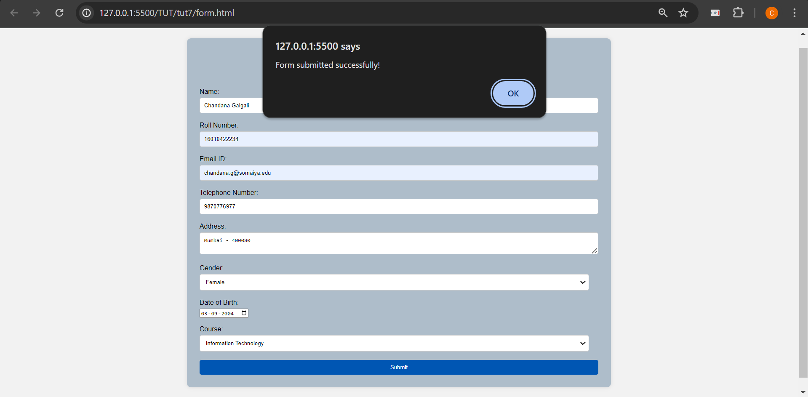

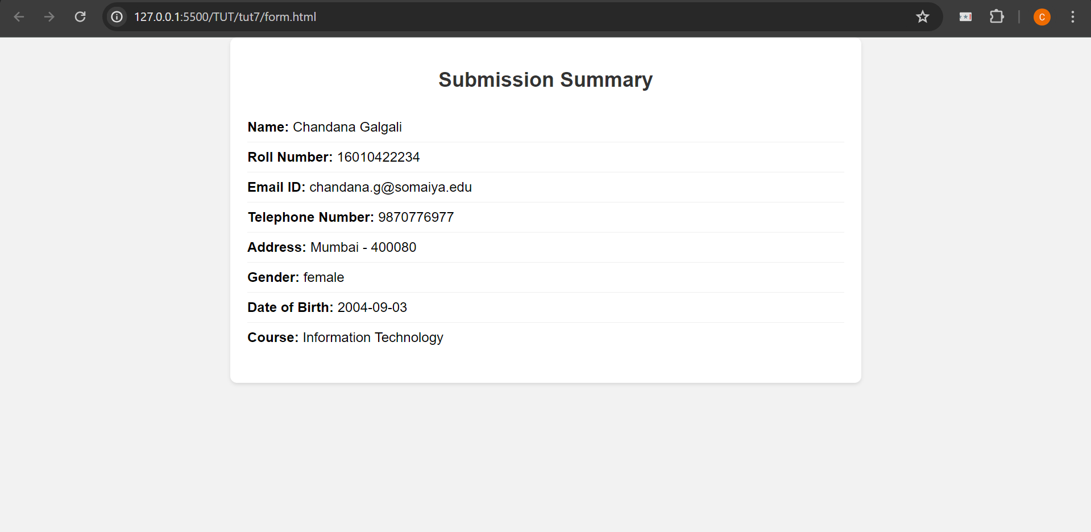

**______________________________________________________________________________**

**Outcomes:** Apply JavaScript and JSON for Web Application development

**______________________________________________________________________________**

**Conclusion: (Conclusion to be based on the outcomes achieved)**

The successful implementation of client-side validation in the designed web page underscores its importance in ensuring data accuracy, improving user satisfaction, and optimizing the performance of web applications. This experiment highlights the effectiveness of integrating client-side validation as a fundamental aspect of web development practices, ultimately leading to more robust and user-friendly digital solutions.

**______________________________________________________________________________**